Sheldon's investigation

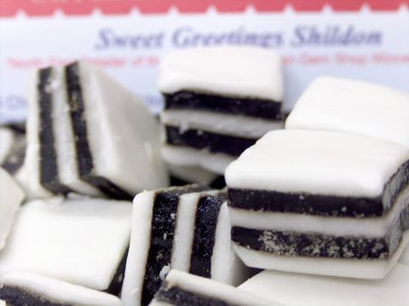
The crime:
When Sheldon came back home from sports yesterday, he noticed that his favorite sweets disappeared. The sweets' bag was empty! He decided to conduct an inquiry in order to find out who stole the sweets.

The suspects:
He entered the rooms of his sisters and brother.
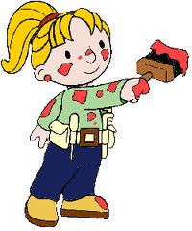
In Judy's room, he noticed a wet red stain. Did a sweet melt on the floor? Judy said she was doing some painting in her room and argued this stain is just some water paint.

In Kevin's room, he found some small white particles on the floor. Is it sugar? Kevin argued he was tidying his room and these particles must be some dust.
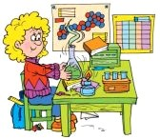

In Alicia's room, he also found white particles. She argued she was working on a science project on starch, and some starch had probably fallen down.

The pieces of evidence:
Sheldon carefully read the tag of the sweets' bag and found the ingredients: Sugar, glucose sirup, water, gelatin, citric acid, malic acid, flavouring, colouring ( E120, E100, E163, E133).

“It will be easy to find out who is the liar and stole my sweets!” said Sheldon. “I just need to remember the chemical tests I have studied at school; I am going to ask the specialists of chemistry to help me”. He took samples of the evidence from each room and brought them to school for you.

The investigation:
For each sample, propose one or several tests in order to check if the suspect told the truth; complete the experiments.

The report:
Write down a report explaining the tests you made (it can be series of schemes) and your conclusions. Don't forget to explain the safety rules for each reagent.
Sheldon's investigation

The crime:
When Sheldon came back home from sports yesterday, he noticed that his favorite sweets disappeared. The sweets' bag was empty! He decided to conduct an inquiry in order to find out who stole the sweets.

The suspects:
He entered the rooms of his sisters and brother.
In Judy's room, he noticed a wet red stain. Did a sweet melt on the floor? Judy said she was doing some painting in her room and argued this stain is just some water paint.

In Kevin's room, he found some small white particles on the floor. Is it sugar? Kevin argued he was tidying his room and these particles must be some dust.

In Alicia's room, he also found white particles. She argued she was working on a science project on starch, and some starch had probably fallen down.

The pieces of evidence:
Sheldon carefully read the tag of the sweets' bag and found the ingredients: Sugar, glucose sirup, water, gelatin, citric acid, malic acid, flavouring, colouring ( E120, E100, E163, E133).

“It will be easy to find out who is the liar and stole my sweets!” said Sheldon. “I just need to remember the chemical tests I have studied at school; I am going to ask the specialists of chemistry to help me”. He took samples of the evidence from each room and brought them to school for you.

The investigation:
For each sample, propose one or several tests in order to check if the suspect told the truth; complete the experiments.

The report:
Write down a report explaining the tests you made (it can be series of schemes) and your conclusions. Don't forget to explain the safety rules for each reagent.

