Stars

1. Life cycle of a star
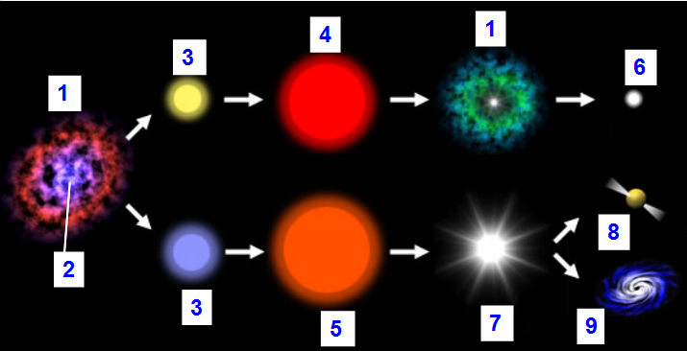
Star
Nebula
Main sequence star
Red giant
Supergiant
White dwarf
Supernova
Neutron star
Black Hole

Word Study: Dwarf and giant are …..........................

Word Study
Magnitude is made up of two word parts:
Magni means “great” or “big”
Tude means the “state or quality of being”
Magnitude means “the quality of being big”.
2. Star magnitude

Magnitude number
Increasing brightness
-27 -26-5-4-3-2-10123
Sun
-26.7
Sirius (brightest star in night sky)
-1.4
Rigel
0.1
Altair
0.8
Aldebaran
0.9
Deneb
1.3

What does the magnitude number measure?
….............................................................................................................................................................................................................................................................................................................
How is the magnitude of a bright star? Of a dim star?
….............................................................................................................................................................................................................................................................................................................….............................................................................................................................................................................................................................................................................................................

3. The Hertzsprung-Russell Diagram
Increasing brightness
The H-R diagram groups (classifies) stars by magnitude and temperature

How are stars near the top of the diagram?
…...........................................................................................................................................................................................................................................................................................................How are stars near the bottom of the diagram?
….............................................................................................................................................................................................................................................................................................................How are stars on the left side of the diagram?
….............................................................................................................................................................................................................................................................................................................How are stars on the right side of the diagram?
…............................................................................................................................................................................................................................................................................................................
Is a white dwarf bright or dim?
…....................................................................................................................................................
Where are the giant stars found on the diagram? Where are the blue stars?
…....................................................................................................................................................…....................................................................................................................................................
Which is hotter, a supergiant or a red giant?
…...................................................................................................................................................….....................................................................................................................................................

4. Pictures in the sky: constellations
What are constellations made of?
…....................................................................................................................................................…....................................................................................................................................................

5. Exercises
Check you understanding: Explain accurately your answer (for example, specify which diagram you use)
1. From Earth, how bright is the sun compared to other stars?
2. Which is hotter, the sun or a white dwarf?
3. As seen from Earth, the star Betelgeuse has a magnitude number of 0.5. Is it brighter or dimmer than Sirius? Is it brighter or dimmer than Altair?

Writing
Explain the difference between a red giant and a white dwarf. Include information on size, magnitude, temperature, and how the stars change. Write a paragraph.

Research on internet and talk : http://www.windows2universe.org/mythology/const_nav.html
Read the internet pages “myths about constellations” and “Explore Myths about Constellations”. Prepare a 5 minutes' talk on one of these myths. (You may use a slide show)

